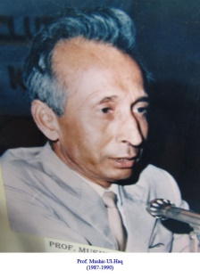**Musheer-ul-Haq**

**About:** On April 6 morning, Haq had received a call from Kashmir’s then Governor Jagmohan, confirming his request for an appointment. After meeting with Jagmohan, Haq’s car drove to his office at the Varsity where he met with the registrar and the developmental officer till it struck 1 pm on the clock. At this time, the VC, along with his personal secretary, left for Friday prayers when they met their abductors. The car drove away for a few kilometers till it reached a locality in old Srinagar city where the VC was shuffled into a standing red Maruti jeep along with Gani. His driver was allowed to go and the jeep sped up, disappearing into the narrow alleys of Fateh Kadal. It’s April 6 in 1990. An armed rebellion has broken out in Srinagar against Indian rule. Four armed men are lurking outside the University of Kashmir. A white ambassador car starts off from the vice-chancellor’s lodge and makes its way towards what is now Sir Syed Gate of the Varsity. Inside the car is Prof Musheer-ul-Haq, the vice-chancellor, his personal secretary, Abdul Gani and an orderly. Haq is on his way to offer Friday prayers. When the car approaches Teacher’s Apartment, it slows down to make a right turn towards the gate when the four men sprung to action, brought the car to halt by pointing gun at the driver from a distance, forcibly got in and ordered the driver to move without making any fuss.

**Murdered on:** 6 April 1990

**Attack details:** An armed rebellion has broken out in Srinagar against Indian rule. Four armed men are lurking outside the University of Kashmir. The government had buckled under pressure and released the militants. Ms Rubaiya was set free after six days. Two hours after their release, the freed militants were given a rousing welcome at Rajouri Kadal in Srinagar.

**Reason to him target:** The news of vice chancellors kidnapping was announced in the evening news broadcast on Doordarshan. The kidnapping was a watershed moment in the advent of armed rebellion in Kashmir. The State government faced criticism for bending to militants’ demands.

**Occupation:** Prof Musheer-ul-Haq was the vice-chancellor of University of Kashmir.

**Belief:** The targets should be government officials and collaborators, not the sons and daughters of soil.

**URL** **:** <https://en.wikipedia.org/wiki/Mushir-ul-Haq>

